Solution Requirements Specification

For

OnBase Workflow Automation Project: Facilities Management Key Request

Version 1.0

Prepared by Jeffrey Greene

OnBase Coordinator/Analyst

August 30, 2016

Table of Contents

1 Introduction 3

1.1 Purpose 3

1.2 Document Conventions 3

1.3 Intended Audience and Reading Suggestions 3

1.4 Project Scope 3

1.5 References 3

2 Solution Summary 4

2.1 Document Workflow Diagram 4

2.2 University Key/Access Credential Request Form Field Matrix 5

2.2.1 Form Section 1: Identification 6

2.2.2 Form Section 2: Requestor Information 6

2.2.3 Form Section 3: Request Type 7

2.2.4 Form Section 4: Building Access 8

2.2.5 Form Section 5: Replacement/Missing Key(s)/BayCard 9

2.2.6 Form Section 6: Students 9

2.2.7 Form Section 7: Required Approvals 10

3 Business Process 10

3.1 Business Process – Requesting Department 10

3.1.1 College Based Request 10

3.1.2 Administrative Based Request 11

3.2 Business Process – Cashier’s Office 11

3.3 Business Process – Facilities Management 11

3.3.1 F.M. – Main Office 11

3.3.2 F.M. - Locksmith 11

4 Solution Training and Support 11

5 Other Requirements 11

A Appendix – Project Team 12

# Introduction

## Purpose

This document provides an OnBase content management system/workflow solution proposal based on the business requirements gathered during discovery sessions between CSUEB’s OnBase Coordinator/Analyst and the Facilities Management Department.

## Document Conventions

## Intended Audience and Reading Suggestions

This document is distributed to CSUEB stakeholders for review and approval.

## Project Scope

* Provide a consolidated UI for key/access requests.
  + Existing form modeled solution.
  + Tracking of additional related forms and receipts, via document integration.
* Provide automated verification of credentials based on the existence and status of indicated NetID, as input on the access request form.
  + Auto-populate access request form fields based on existing PeopleSoft applicant information records.
* Load balance access request workflow to those whom are authorized to process such workflow, workflow pattern flexibility.
  + Role based accessibility.
  + Automatic user reassignment.
* Provide a digital and logical store of access request forms, and associated documentation linked to such request.
  + ITS managed document storage, and backup.
  + Cloud omnipresence.
* Facilitate automatic tracking of access requests.
* Provide automated email notification upon processing document through workflow lifecycle.

## References

Professional Services Proposal, OnBase Workflow Automation Project: Facilities Management Key Request. Document Version 1.0.1, August 17, 2016

# Solution Summary

University Key/Access Credential Request Form is the primary form used in a business process workflow designed to grant access to building resources. The OnBase content management solution itself automates, captures, and stores the requisitioning, data management and cataloging of the current paper-based University Key/Access Credential Request Form and associated workflow processes. The solution will capture and import associated documents into the workflow process, like the Master Key Authorized Letters from appropriate department administrators, Cashier’s deposit receipt for students, and Facility Management’s Key Card. These associated documents will be represented within the solution.

## Document Workflow Diagram

This diagram shows the various states in the business process and the critical activities occurring through the process.

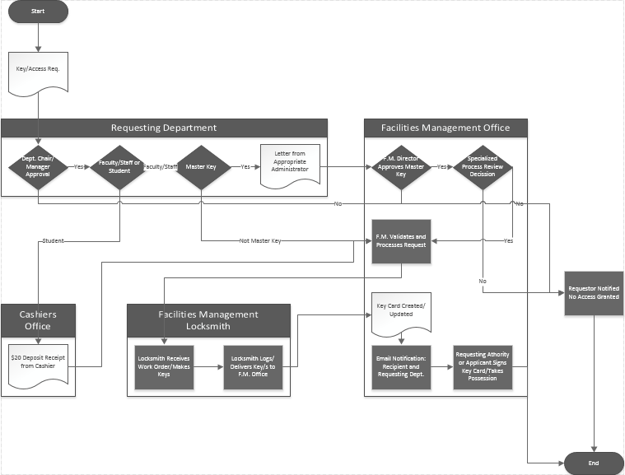

## University Key/Access Credential Request Form Field Matrix

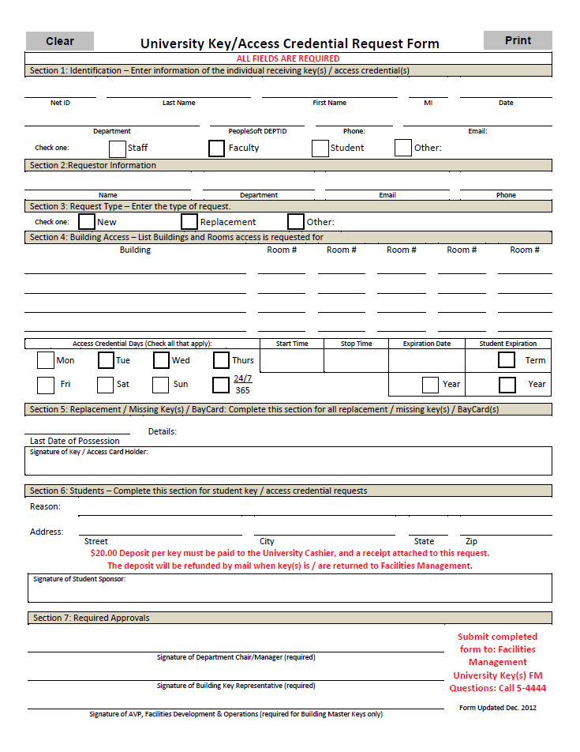

Below is a list of all fields and business logic required on the University Key/Access Credential Request Form, broken down into the seven sections found on the form itself. Supporting documents include:

* Master key letter of approval from appropriate department administrator.
* Key deposit receipt from the Cashiers Office.
* Facilities Management key card.

### Form Section 1: Identification

Below are the thirteen fields of the identification section found on the University Key/Access Credential Request Form. Of particular interest is the PeopleSoft ‘NetID’ field. The NetID field will act as an unique keyword for both form autofill and a relational identifier for related documents.

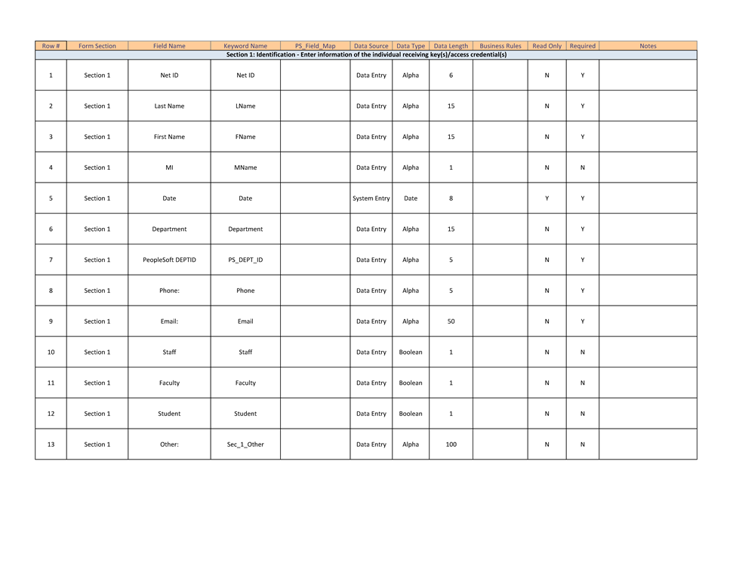

### Form Section 2: Requestor Information

This section, the Requestor Information section, has four fields—all alphanumeric datatypes.

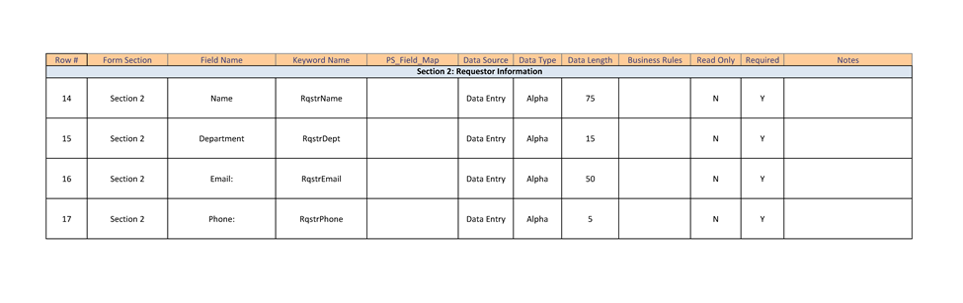

### Form Section 3: Request Type

Section 3 has three boolean typed checkboxes, leveraging exclusive or logic. Should the ‘Other’ checkbox be selected, the fourth field (an alphanumeric textfield) will become active…and data-entry will become active.

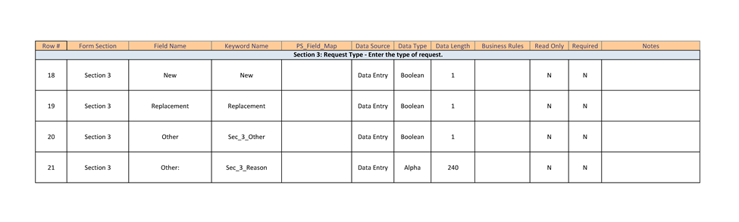

### Form Section 4: Building Access

The building access section will have a repeating line-item data set containing both building identifiers and room numbers. Of particular interest with respect to business logic are the fields specifying access days, start-stop times, and expiration dates for both faculty/staff and student applicants.

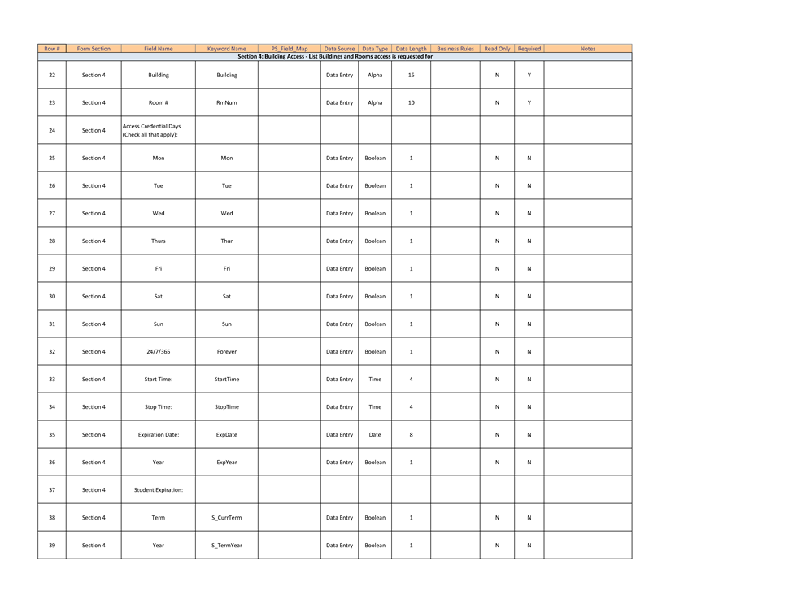

### Form Section 5: Replacement/Missing Key(s)/BayCard

For any type of replacement/missing keys/cards these important fields recording the last date of possession and the details surrounding the mishap are required; otherwise, these fields become hidden or non-editable. Do note the signature of the key/access holder will be required should there be an access mishap—implying statement of truth.

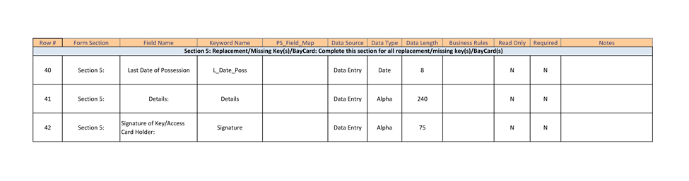

### Form Section 6: Students

Should the key/access applicant be of student status section 6 will contain the salient information with respect to student/sponsor. That the signature of the student sponsor is required (whom must be faculty/staff) implies binding of good faith, and that the sponsor presumably assumes responsibility for inappropriate use of access privileges. Note that should the applicant be a student and this section becomes active, a Cashier’s deposit receipt becomes necessary. A Cashier’s deposit receipt will then be associated with this application, related by the applicant’s NetID.

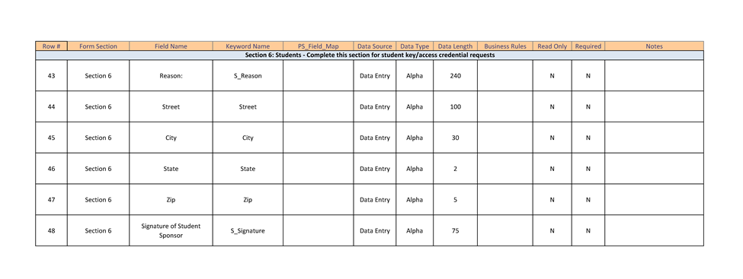

### Form Section 7: Required Approvals

Section 7 will require approving authority’s signatures. Approving authorities are typically department chairs/managers, building key representatives, and in the case of master key requests the AVP of Facilities Development & Operations will be required. These signatures will be burned into the document itself.

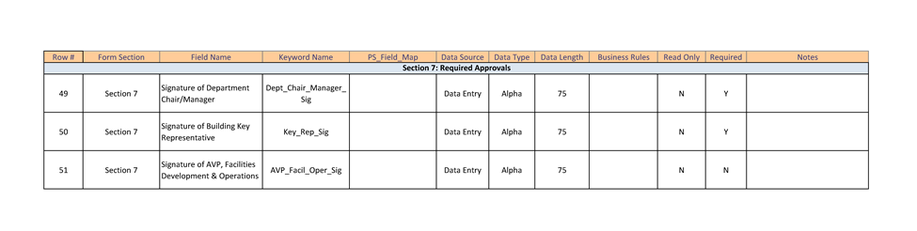

# Business Process

There are three business process workflows, each with their own business processes. These process workflows are related to the requesting department, the Cashier’s office, and Facilities Management. The Document Workflow Diagram graphically represents these processes, and illustrates how each business process workflow relates to the other two.

## Business Process – Requesting Department

Typically, the requesting department is a college or department within the college…but that may not always be the case, e.g. administrative department outside any college of scope have key/access needs as well.

### College Based Request

College based key/access requests are typically divided between academic and administrative business functions. There is a clear separation of duties between academic program management and college logistical management. Academic program management and the staffing of its intelligentsia to meet the needs of the enrolled students…these responsibilities are mutually exclusive from department logistical administration. In other words, both Deans and Department Chairs only deal with academic maters, and rely on their administrative arm to collate/advise department leadership on matters such as room assignments. Therefore, it becomes necessary to have an administrative staff person act as “Building Representative.” Such a Building Representative would themselves have no responsibilities with respect to academic program management/development. Nevertheless, these Building Representatives have a clear role as logistical collators. College based Administrative Analysts are typically designated as Building Representatives due to the nature of their duties, managing data repositories: class scheduling DBs, specific and unusual professor access requests (e.g. the need for lab access, rotating and/or otherwise), managing access to suites of rooms, office assignments for professors/lecturers, and student access. Because of the special needs of academic leadership, i.e. Deans and department Chairs, it is not possible to eliminate the role of Building Key Representative, with respect to the colleges. Again, this is because College leadership tends to abstract their logistical needs and affairs to their respective administrative staff members.

### Administrative Based Request

Pure administrative departments at the University do not have the added responsibility of managing and maintaining dynamic curriculum above their charter. Administrative departments themselves have only to execute their business function, and do not have rotating access requirements as compared to academic departments. Pure administrative departments like Finance or Purchasing simply need to identify their respective employees, and the employee’s need for access to department offices or to a specific room associated with the department—like an office supply room, or shared printer room. Additionally, many administrative departments share a single building, like the SA building. For example, it would be unreasonable for the Student Administrative building to have a Building Key/Access Representative primarily because there are so many autonomous departments and offices, like The Office of the President. It would be unreasonable to force coordination between The Office of the President and the many other departments which share the Student Administrative building.

## Business Process – Cashier’s Office

The Cashier’s Office has a unique workflow completely abstracted from both access requesting departments and Facilities Management. The Cashier’s Office’s Key/Access workflow centers on students. Only in the special case a student has an active access request generated by a requesting department does the need arise for associated documentation to the request form itself become necessary – a key deposit receipt. The Cashier’s Office generates Receipt # and an Amount received, and this receipt is attached to the University Key/Access Credential Request Form. These two fields relate to the accounting system currently used in the Cashier’s Office, and are necessary for auditing requirements; in other words, these two fields link the key/access request form to the student’s key deposit and thus provide an auditing trail which cannot be eliminated due to state and general US GAAP procedures. These two fields will be added to the University Key/Access Credential Request form, Section 6: Students. Dividing the ‘Amount Paid’ field by the deposit amount per key provides Facilities Management the ability to verify the quantity of keys to produce.

## Business Process – Facilities Management

Facilities Management’s key/access request workflow has a need to move access request applicant form validation from the physical production of access resources. There is a clear logical need to validate applicant requests in the administrative center of Facilities Management before a work order is produced and sent to the locksmith. Consolidation of both accounting and validation of access requests within the administrative arm of Facilities Management streamlines University auditing and trace-back policy requirements while freeing the locksmith

### F.M. – Main Office

### F.M. - Locksmith

# Solution Training and Support

# Other Requirements

1. Appendix – Project Team

|  |  |  |
| --- | --- | --- |
| **Name** | **Role** | **Department** |
| Andrews, Robert | Dir, Facilities Ops | FDO - Facilities Management |
| Bollinger, Philip | Accounting Technician II | Cashiers and Student Finance |
| Davenport, Wanda | Admin Analyst/Spclst 12 Mo | College of Business & Econ |
| Desousa, Alvaro | Director, Business Ops | FDO - Business Operations |
| Greene, Jeffrey | OnBase Coordinator/Analyst | Finance |
| Highstreet, Terry | Supervising Locksmith | FDO - Maintenance |
| Miller, David | Mgr, Trades | FDO - Maintenance |
|  |  |  |
|  |  |  |
|  |  |  |
|  |  |  |
|  |  |  |
|  |  |  |
|  |  |  |
|  |  |  |
|  |  |  |